**MICRON HACKATHON 2022**

***TEAM : CONSTANT VARIABLES***

**STEPS FOR EXECUTION:**

1. Run candidate_optimization.py

The Resulting output will look as follows:

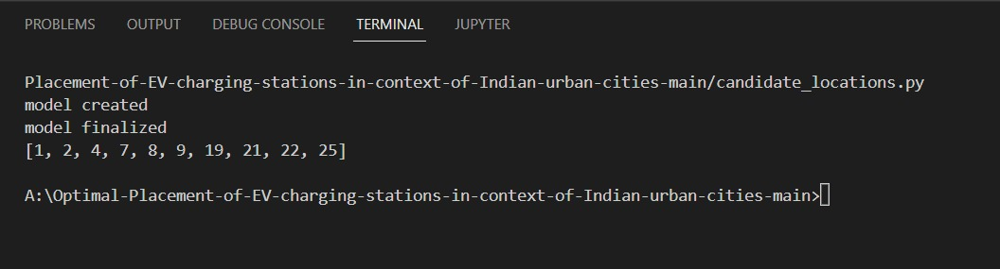

The Output displays the optimal nodes from 33 bus networks considering all the requirements like already existing stations, distance and the demand for the charging stations in that particular bus network.